**Wireguard**

Ruben:

**publickey**

7ezSBINE40rg9Jjk4m8PstrEyS50xrjqtxI5w+93rls=

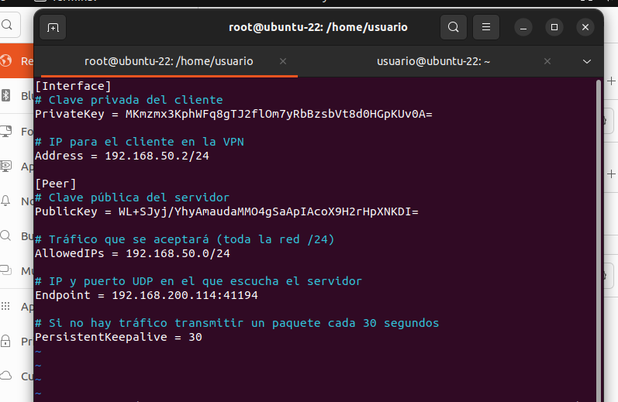

Angel:

**Publickey**

WL+SJyj/YhyAmaudaMMO4gSaApIAcoX9H2rHpXNKDI=

HL+S.Jyj/YhyAmaudaMMO4gSaApIAcoX9Hs2rHpXNKDI=